Project Report Template for “Fresh Bites Catering”

Contents

1. INTRODUCTION 2

1.1 Overview 2

*1.2* *Purpose* 2

*Preparation and Maintanence of ZOHO Books for Fresh Bites Catering* 2

2. PROBLEM DEFINITION & DESIGN THINKING 3

*2.1 Empathy Map* 3

2.2 Ideation & Brainstorming Map 5

3.RESULT 6

4. ADVANTAGES & DISADVANTAGES 7

5. Application: 8

6. Conclusion: 8

7. Future scope: 8

8. Appendix 8

# INTRODUCTION

## 1.1 Overview

* Fresh Bite Catering specialize in providing catering for a variety of occasions, including breakfast, lunch, dinner, and
* snacks, as well as reception and cocktail service. No matter what type of event you're hosting, we have the expertise and resources to make it a success.
* This project is using by Zoho in accounting and financing.
* With the help of zohobooks of accounts we create profit and loss account and balance sheet and GST (18%). Calculate for the Fresh Bites Catering.

## *Purpose*

* Fresh Bite Catering cater for schools, colleges and universities. We serve a wide selection of food and beverages, whilst keeping in mind the nutritional needs of students by offering a range of healthy meal plans. But we don't just serve any food – we also prioritize the nutritional needs of students.
* It is create for the purpose of prepare profit and loss account, balance sheet and prepare GST report for the Fresh Bites Catering.

## *Preparation and Maintanence of ZOHO Books for Fresh Bites Catering*

Fresh Bites Catering, a catering service, utilizes Zoho Books to manage their sales, track inventory, and handle invoicing. They can generate professional invoices for clients and track expenses related to ingredients and supplies. Zoho Books helps them maintain accurate financial records and streamline their catering operations

# 2. PROBLEM DEFINITION & DESIGN THINKING

* It create method of preparation of accounting profit and loss account, balance sheet and GST calculation is complicated.
* It recent day’s new technologies allotted. Here we use Zohobook as a tool for creating profit and loss account, balance sheet and GST report.

## 2.1 Empathy Map

* An empathy map is a collaborative tool teams can use to gain a deeper insight into their customers. Much like a user persona, an empathy map can represent a group of users, such as a customer segment.
* Empathy Maps are a simple yet powerful tool that can help product managers to better understand their customers' needs and pain points. visual representation of the customers' thoughts, feelings, and behaviors.

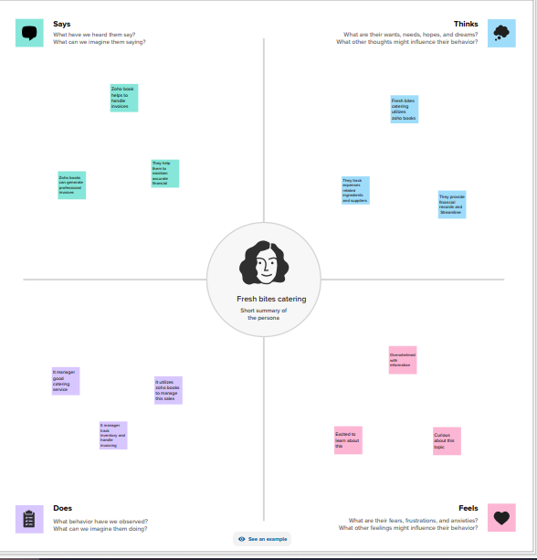

## 2.2 Ideation & Brainstorming Map

* Brainstorming is a group creativity technique by which efforts are made to find a conclusion for a specific problem by gathering a list of ideas spontaneously contributed by its members.

What is brainstorming explain?

* Brainstorming is a group problem-solving method that involves the spontaneous contribution of creative ideas and solutions.

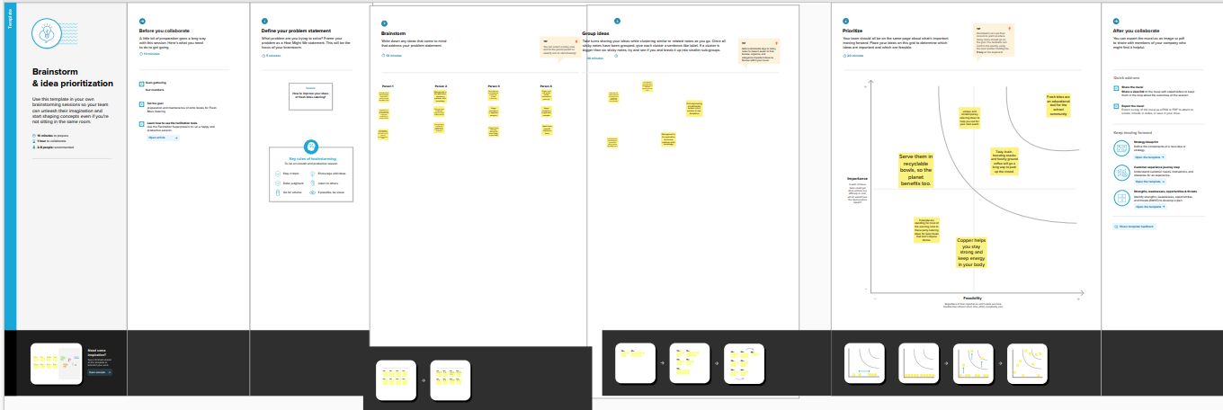

# 3.RESULT

Cash flow of the company financial operation is given below:

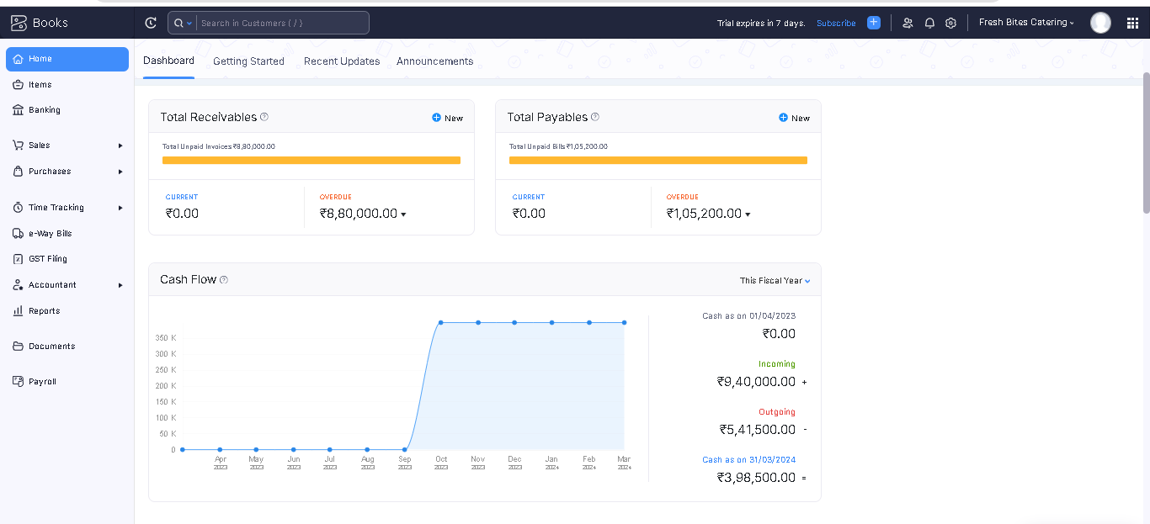

Sales and purchase operations of the company:

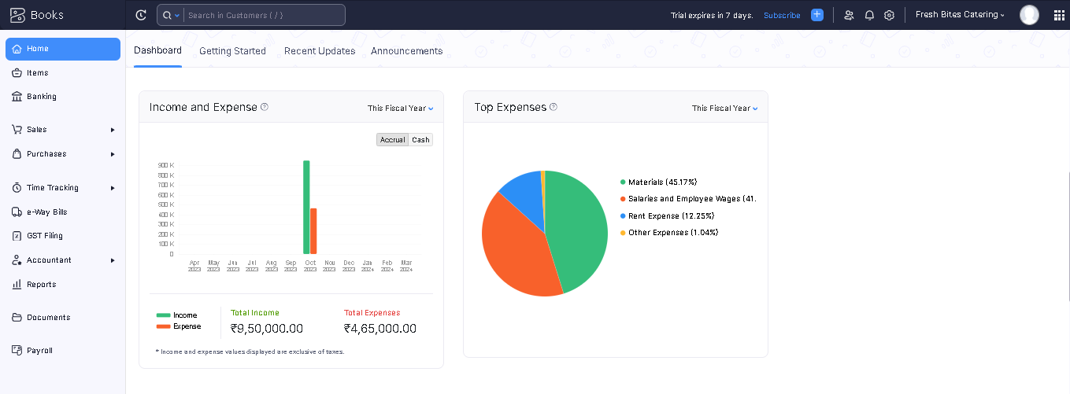

# 4. ADVANTAGES & DISADVANTAGES

Advantages:

* Catering food will help you throw an amazing party.
* Qualified Experts.
* Service on. Schedule.
* Multi Cuisine Menus.
* Attractive Pricing.
* Experienced Professionals.
* Fresh Quality Ingredients.

Disadvantages:

* It’ll be difficult in the beginning of your career.
* Time tracking must be tied to project.
* Difficult to modify bills.

# 5. Application:

* This application used to maintain the company details and ledger accounts, profit and loss account and balance sheet of the company Mega store supplies.

# 6. Conclusion:

* It is a service that delivers, cooks and serves foods on site at a clients location.

# 7. Future scope:

* Preparing and storing food safety before during events, setting up all tables and food service areas with chairs, lines and dishes, serving food to guests at event. It also helped to reduced the work of the accountants.

# 8. Appendix

* Approved development
* Future assessment
* Plan of development
* Free delivery and pickup